**CB[1] – Enrichment Cortland Watson**

**Type in your score here 🡪 __49__ out of 49 points possible**

1. (5 points) Ponder/Reflect Exercise – Reflect on what you have learned from this portion of the class. Examples of what you can do are: a brief outline of material covered, insights you gained from class or personal study, or items you feel that you need to follow up or work on. (3-5 sentences)
   1. This week I learned more about the importance of blocking. I have been able to see through the data and analysis, as well as decomposition that blocking is a way to control for nuisance variables and that using them brings power. I have been able to see that by blocking, we are using more ways to randomize and control for unwanted interference.
2. #B1 on pages 256-7
   1. (4 points)

|  |  |  |  |  |
| --- | --- | --- | --- | --- |
| Week | Diet | Cow | Yield | Average |
| 1-6 | Roughage | 1 | 608 |  |
| 13-18 | Roughage | 2 | 711 | 695 |
| 7-12 | Roughage | 3 | 766 |  |
| 7-12 | Partial Grain | 1 | 716 |  |
| 1-6 | Partial Grain | 2 | 885 | 811 |
| 13-18 | Partial Grain | 3 | 832 |  |
| 13-18 | Full Grain | 1 | 845 |  |
| 7-12 | Full Grain | 2 | 1086 | 957 |
| 1-6 | Full Grain | 3 | 940 |  |

* 1. (2 points) Roughage-695 Partial Grain-811 Full Grain-957
  2. (3 points) 1-6 (811) 7-12(856) 13-18(796)
     1. It does not look like time of the testing period has a huge impact on the yield. At the same time, it looks like the diet is what makes the difference in the yield. As for the milk decreasing over the course of the experiment, there was a decrease between the last two time periods, but an increase between the first two. This data is inconclusive as to milk yield decreasing over time.
  3. (2 points) 1-723 2-894 3-846
     1. It appears, when comparing the time period to the specific cows, that the cow makes more of a difference than the time period does. There is a 170 difference between the high and low cow, while only 60 difference between time periods.
  4. (2 points) The factor of interest in this design is experimental. We are controlling all that we can about the experiment, from the cows, to the time periods, to the diet that the cows get during that time period. Observational studies would not work in this design because of the nature of observational studies. We are not able to control for nuisance variables in an observational study.

1. Now use the data from the previous problem (found in Figure 7.7 on page 254) to conduct the formal analysis using software (SAS or R). For R, you can either (1) type the data into an excel spreadsheet, save the file as a .csv format, and read in the data; or (2) type the data directly into R. For SAS, the SAS filename is *milk*. Please do the following:
   1. (5 points) Check the assumption of residuals being normally distributed using **software**.
      1. 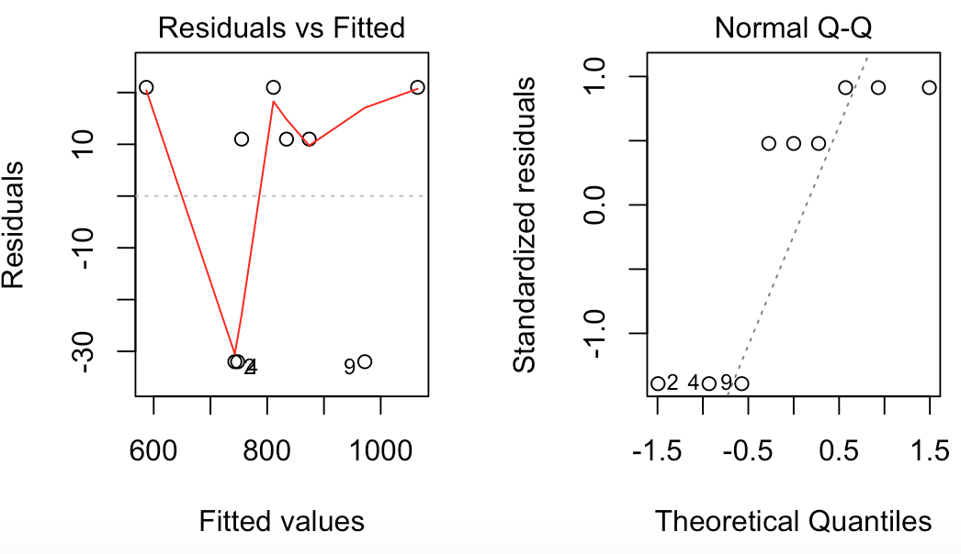This data does not look like it normally distributed and it does not look like the variance is favorable. We will still move forward, so that we are able to run the test.
   2. (4 points) Get an ANOVA table using **software** 
      1. 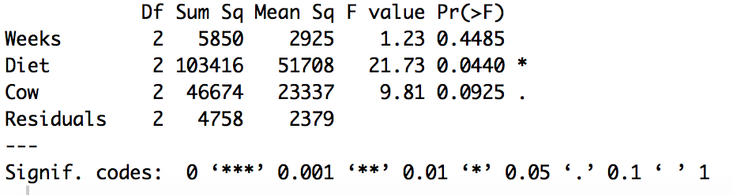This shows us that the Weeks and Cow factor do not play a significant role in the analysis and they do not block effectively. At the same time, the treatment, or the diet show significant results indicating that the manipulation of diet does change our target variable.
   3. (5 points) For the effect of interest: i) state the null and alternative hypotheses, ii) give the test statistic, iii) give the degrees of freedom, iv) state the p-value, v) determine whether you should reject or not reject the null hypothesis, and vi) write a sentence which gives an appropriate conclusion.
      1. The null hypothesis is that the means are equal to 0. The alternative is that one of the means is not 0.
      2. The test statistic is:
         1. Weeks = 1.23
         2. Diet = 21.73
         3. Cow = 9.81
      3. The degrees of freedom are:
         1. Weeks = 2
         2. Diet = 2
         3. Cow = 2
         4. Den = 2
      4. The p-values are:
         1. Weeks = .4485
         2. Diet = .0440
         3. Cow = .0925
      5. We have sufficient evidence to reject the null hypothesis that one of the groups is different with diet. We have insufficient evidence to reject all other null hypotheses.
      6. We are able to conclude safely that Diet has an effect on the yield of the cows, therefore we should feed the cows full grain.
   4. (2 points) Did the nuisance variables (cow and time period) have substantial impact on the yield?
      1. The only nuisance variable that had substantial impact was that of diet. All of the others did not have a substantial impact.
2. A cross-sectional study was conducted in East Boston to determine if smoking affects the pulmonary (lung) function of youths. The subjects in this observational study reported their age, gender, and if they currently smoke. The researchers also measured the height and forced expiratory volume (FEV) of each of the subjects. FEV is a measure of pulmonary function, and higher values are more favorable. FEV is measured as the volume of air (in liters) that is expelled in the first second after the lungs are filled. The primary objective of this study was to determine if smoking (SmokingStatus) affects the subjects’ FEV. Use height as a covariate in the analysis. Use α=0.05.
   1. Check if there is an interaction between the covariate and Smoking Status (Show the table)(3 pts).
      1. 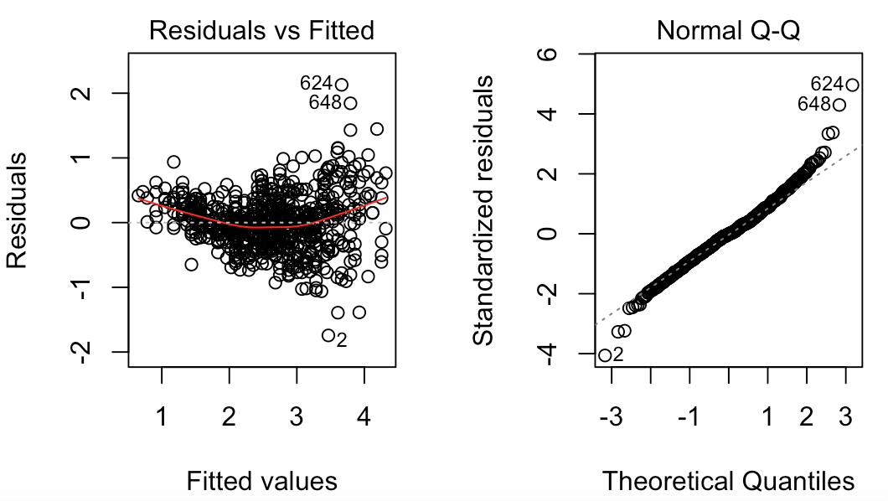By checking the assumptions we are able to see that this data is not very favorable. The variance is megaphone shaped, the normality tails off on both ends, thus indicating that the data is not very promising or normal.
      2. 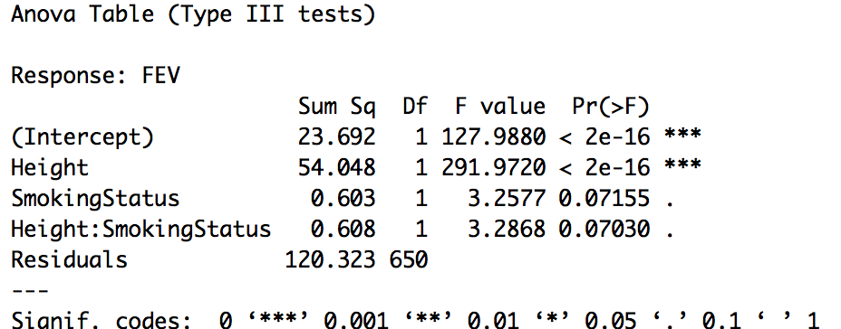This table is able to show us about the interaction. It teaches us that the intercept and the height are significant.
   2. Run the ANCOVA model (show the table) and summarize the results (3 pts).
      1. 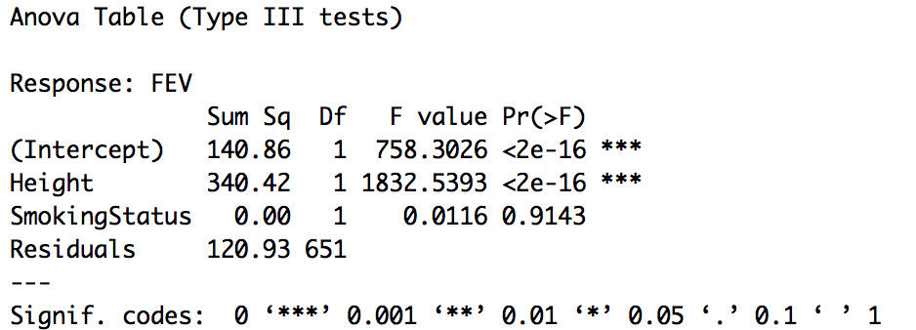
   3. Do a qqplot and histogram of the residuals to see if we can assume normality (3 pts).
      1. 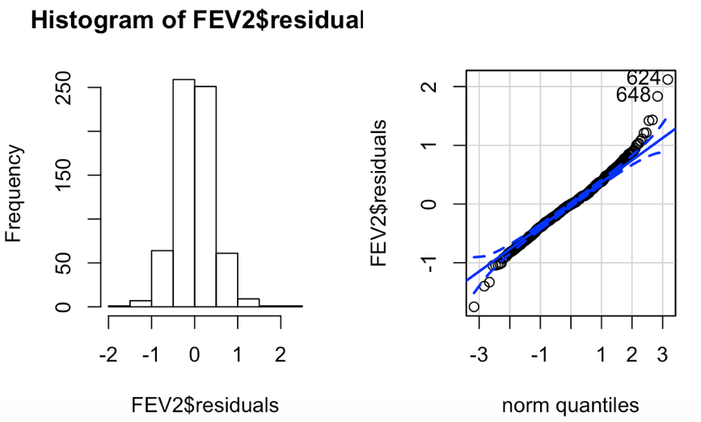
   4. Now use Age as a covariate. Check to see if there is an interaction between the covariate and Smoking Status (Show the table). What do you conclude based on this (3 pts)
      1. 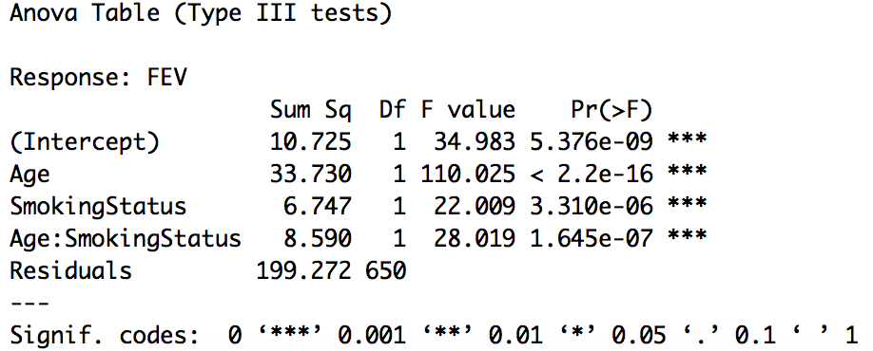
      2. 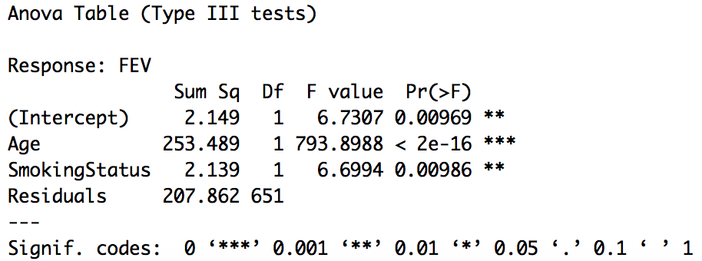
      3. 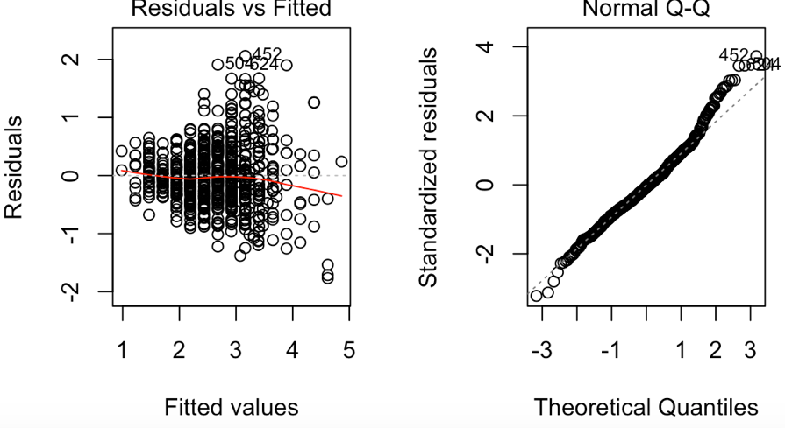
      4. 